**Microservices with Spring Boot 3 and Spring Cloud**

2. Microservices with API gateway:

Creating Microservices for account and loan

AccountController:

package com.cognizant.account.controller;

import org.springframework.web.bind.annotation.GetMapping;

import org.springframework.web.bind.annotation.PathVariable;

import org.springframework.web.bind.annotation.RestController;

import java.util.Map;

public class AccountController {

@GetMapping("/accounts/{number}")

public Map<String, Object> getAccount(@PathVariable String number) {

return Map.of(

"number", number,

"type", "savings",

"balance", 234343

);}

}

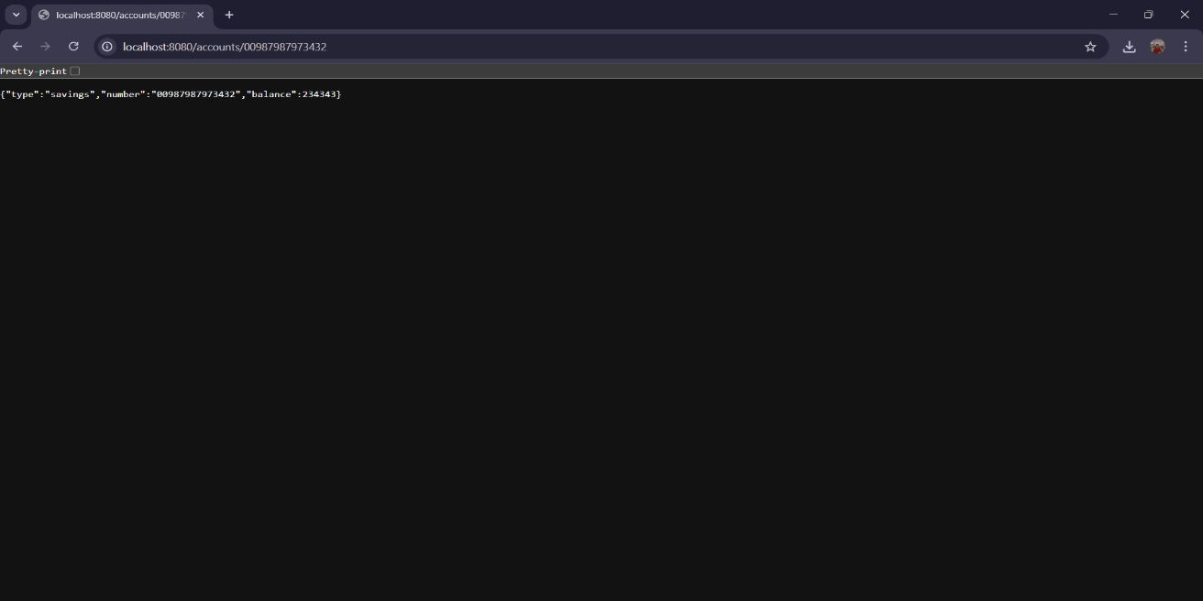

LoanController:

package com.cognizant.loan.controller;

import org.springframework.web.bind.annotation.GetMapping;

import org.springframework.web.bind.annotation.PathVariable;

import org.springframework.web.bind.annotation.RestController;

import java.util.Map;

@RestController

public class LoanController {

@GetMapping("/loans/{number}")

public Map<String, Object> getLoan(@PathVariable String number) {

return Map.of(

"number", number,

"type", "car",

"loan", 400000,

"emi", 3258,

"tenure", 18

);

}

}